Lapse rate manual

This is geared towards both students and faculty! Please add to or revise it as you see fit. My intention here is to provide a set of procedures to be consistent across blocks. However, I’d rather have data than consistency. I’ve done my best to solve problems ahead of time, but there I will have undoubtedly missed things. If there’s a good reason to deviate from what I’ve laid out in this document, then do it! I trust all of your judgement. I can’t adequately express how lucky I feel to be working on this with such a great group. I appreciate you!

# How to use this document

In MS Word, locate the “view” tab, and check the “Navigation Pane” box. In the sidebar, click the bullet list icon to show the outline of this document.

# Quickstart

## Warning! Drill & auger operation

This drill is stronger than your body is, and it is more than capable of breaking your wrist. Using the drill auger is the most hazardous aspect of this project. Take the extra second to double check what you are doing before use.

## Overall goals

## Field day outline

### Day before

1. Charge drill batteries
2. Package sensors in solar shields and mount to stakes
3. Pick approximate stake placement locations
4. Fill out pre-deployment information
   1. Record sensor model, SN, and whether it is shielded

### Day of

1. Select site, and take a GPS point
2. Attach the extension to the main pole
3. Drill hole and place pole
4. Take a photo of the deployment, ideally including any identifiable view/features that could aid in finding the stake in spring

### **\*\*Record the following information in the field notebook\*\***

1. Latitude, longitude, and elevation of the installation
2. Length of stake above and below the surface
3. Height of each sensor above the surface
4. Time of deployment
5. Any notes about the deployment or nearby identifiable features

### Back in camp

1. Fill out the deployment spreadsheet
2. Transfer photo to field computer
3. Transcribe any other field notes

## Leaving camp checklist

1. Installation hardware
   1. **Deployed** sensors
   2. 4 m pole
   3. 2 m pole
   4. Plywood spacer
   5. HVAC tape
   6. Hose clamps
   7. Plastic zip ties
   8. Metal cable ties
2. Drill auger
   1. **Charged** battery
   2. Drill
   3. Drill auger adapter
   4. 2-3x Auger flights
   5. Cutting head
3. The rest
   1. Tape measure/laser measure
   2. Extra hardware kit[1]
      1. 2 zip ties, 2 cable ties, 3 short screws, 2 long screw, 1 drill bit, 1 driver bit, 4” x 6” mylar, 2’ HVAC tape, extra plywood spacer, 1 hose clamp, 1 ski strap
      2. Optionally CA or PU glue
   3. Field notebook, pencil
   4. Phone with HOBOConnect & mapping app
   5. Mini pliers/multitool

# Preparing a sensor installation

## Deployment schematic

Insert drawn Pic of pole in snow

## Mounting the sensor

Bamboo has great properties but can be tricky to work with. I don’t have any experience with bamboo, so I took a while to mess around with various options for affixing a plywood plate for the sensor. I would encourage you to do something similar to get a feel for when/how it fails. I’ll try to make sure there are a couple extra poles for this purpose. Cut off sections just above the joint and try some ideas.

### Experiments

Here are some of my impressions:

* The most common issue was splitting the bamboo. Any screw into the wall of the bamboo needs to be pre-drilled. Even when predrilled, any screw not running perpendicular to the pole has a solid chance of splitting it. Screws into the joint interface won’t split it.
* For big poles, the interface at the joints is strong to compressive force, but holds screws poorly. However it does hold screws well for the small poles. At the thin end of the small poles, the weak interface material found on the larger poles is almost absent. Instead, the walls pinch together and do a much better job of holding the threads. For the large poles, a viable alternative would be to cut a few inches above the joint, then fill the interior of the bamboo by gluing in a wooden plug made from a dowel that can be screwed into instead.
* Careful not to cut the poles too close to the joint. Most screws have their most aggressive threads near their end, and are often unthreaded near the head (depending on what screw I settle on, this might not be an issue).
* The exception to this will be for affixing a sensor to the top of a large pole. Cutting the pole right at the joint gives a continuous flat surface. It may be bad for screws, but it will be excellent for glue. With that much surface area, a bond using PU glue will be extremely strong.
* I bent a small pole almost 90 degrees before it snapped, which is crazy! It also failed in a great way, kind of like a cartoon gun barrel. It was no longer stiff, but it was still one piece, and I’d guess retained a large portion of its tensile strength. I see this as a good sign that we will be able to recover everything even if the poles fail.
* I tried affixing a small pole to the end of a big pole. I overlapped approximately one joint on each.[2] Zip ties do not cut it here. If you have to use zip ties, use at least 3 and wrap around the joint with HVAC tape. The plywood spacer is a critical piece here, but it is currently unclear to me whether it is better for it to be wider or narrower than the poles.

### Takeaways

* For small poles, a screw and glue will work well to secure a plate to the top. A very small hole can be drilled below the joint for a loop of safety wire.
* For large poles, glue alone should be sufficient to hold the plate to the top, though it should specifically be at a joint and with PU glue.[3] Safety wire or a metal zip tie would be a suitable backup, though I lean towards wire. Avoid wire cable/rope. A dowel plug (secured with PU glue) and screw would also be suitable.
* Use something that can be securely tightened to affix the small poles to the large poles. I don’t trust plastic zip ties for this. Ideally, use 2 hose clamps. Wrap once or twice with HVAC tape to prevent gradual motion.
* Attaching a shielded sensor to the side of a pole should be straightforward. For new pendants, 2 zip ties through the mounting boot is sufficient. For the old pendants, a zip tie around the sensor body is sufficient, with a loop of safety wire passing through hole at the top of the sensor and through the bamboo.
* Tape and/or zip ties are useful as a backup against splitting while installed. But if a pole splits before you install it, just cut the section off or use a different pole.
* There are a lot of ways one could do this, and at least a few of them would work well. Please feel free to iterate on this!

### Instructions

Based on the above experiments, here is a step-by-step guide for how to attach a sensor to the top of a narrow pole:

1. Cut off top of pole so that the first joint is 1-2” from the top of the pole. The length remaining depends on the length of the screw you will use (I’ll ideally have done this for you).
2. Apply PU (Gorilla) Glue to the rim of the pole (CA glue or Titebond 3 wood glue will work in a pinch)
3. Place washer on screw and drive it into the wood plate until the screw is nearly through the plate.
4. Apply small amount of PU glue to the threads of screw.
5. Screw plywood plate to top of pole, with screw centered in the opening of the bamboo and the plywood centered on the screw. The screw should pass through the full thickness of the joint, pulling the plate securely against the top of the pole. Careful to avoid overtightening.

For a thick pole:

1. Cut the pole at the joint to maximize surface area
2. Apply PU glue and plate to the top of the pole

For either case, finish with the following steps:

1. Carefully drill a small hole directly through the bamboo below the next joint. Loop safety wire between the sensor and the mounting boot and through the hole.
2. Apply a small amount of PU glue to the underside of the mounting boot near the screw holes
3. Attach the sensor with 2 screws through the holes on the mounting boot.
4. Tension safety wire and twist pigtail.

Apply a small amount of PU glue between the mounting boot and the plywood at the screw hole. **Do not apply PU glue to the sensor itself.** Screw the mounting boot to the plywood plate.[4]

1. As a backup, drill a hole below the bottom of the screw perpendicular to the bamboo, and opposite the orientation of the plywood plate (e.g., front-back vs. side-side). Drill slowly (light pressure) to prevent bamboo from splitting.
2. Thread a metal zip tie in-between the sensor and the sensor mounting boot, then through the hole. This will hold the sensor to the plywood plate. Orient the cable tie so the head is along the bamboo and the tail of the tie points towards the ground. Tuck the tail into the hole if possible. **Be careful not to cover the light sensor!**Alternatively, use safety wire and twist a pigtail ~2 in.  
     
   You could also use wire cable and cable clamps, but in my experience, these are difficult to tension and more prone to error. The additional strength of the cable is unnecessary, so I’d recommend using wire.

## Additional sensors

* Todo
* Spacing between sensors is arbitrary. Use a round number. I have aspirations of using the data to constrain the height of the snow surface and characterize stability. It’s also for redundancy/solar forcing.

## Drilling the hole

To reiterate the warning from above: if the drill can’t spin the bit, it will spin you and/or itself. Injury is unlikely, but I’ve had it twist my wrist hard enough to be wary, and it also delivered a memorable uppercut to my chin with its battery. If you are worried about the bit seizing (or are using it for anything other than augering), you can start out using the clutch to prevent excessive torque.

### Instructions

Drill the hole such that ~1.5-2.5m of stake is below the surface **at the end of the melt season**. Adjust within this range based on location and the amount of expected melt remaining. For example, slightly shallower at the ice divide since it will be snowed in first. Additional length above the surface is also desirable here so that there’s a chance of it melting out by summer. If you are toward the terminus of the Taku in early July (and your name is Allen), you might want to put it in the full 2.5 – 3m.

I’m most concerned about the stakes surviving fall windstorms. My guestimate is that these are a greater risk for sites downglacier, and where the topography would channel winds from the southwest. Err on the side of putting stakes in too deep.

In the accumulation zone, my sense is to aim for the height of the top-most sensor to exceed the depth of any nearby mass-balance pits by at least 1 m. In the ablation zone, an annual balance gradient of ~6.5 m SWE / (vertical) km is a reasonable approximation. If that doesn’t leave you with a clear choice, send me an InReach message and I can pull up an ELA.

See the following from Kovacs for tips on use:

Additional tips (feel free to add to this):

1. If the auger is seizing/refreezing quickly, try applying a silicone lubricant or oil-based coating (wax perhaps?)
2. Make sure the drill isn’t on hammer mode

## Solar shields

Todo:

# Sensors

## Sensor overview

### New pendants

### Old pendants

### Microstations

# Picking a location

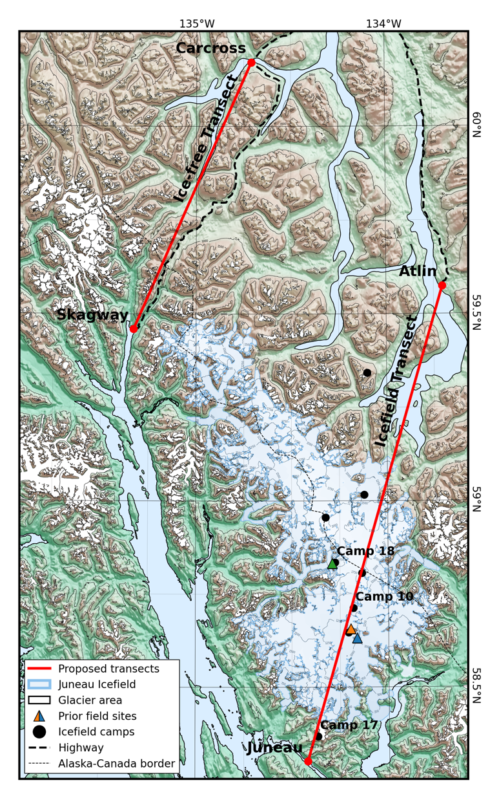

Todo: Use your best judgement!

Keep in mind the local slope gradient, aspect, and wind/avalanche redistribution. A convex slope may be advantageous in high-accumulation areas, or a north-facing aspect in high melt areas. If these features aren’t too large, I don’t think it will have a huge effect on the results.

## Icesat2

Todo: If possible put sensors right on the Icesat2 line

## Camp-to-camp

Todo: Linking weather stations between camps would be great, even if it isn’t exactly along the transect. If we have enough, we can also put microstations at small camps that don’t have a weather station (C9 at least?)

# HOBOconnect (new pendants)

Todo: Deployment settings & tutorial

# HOBOware (old pendants)

Todo: Deployment settings and tutorial

1. Enough to get a pole 90% of the way there from scratch if for some reason it needed to be redone. Never a bad idea, but you can probably ditch it for just one pole. Consider doubling for >= 3 poles.
2. Though, I suspect joints are more likely to break from bending and should probably be centered in the overlap
3. PU glue expands, making it particularly good for end-grain joints. It also has a higher breaking strength than wood glue or CA glue for these materials.
4. If, for some reason, you are using an old pendant for the top of the pole, omit this step and instead apply PU glue to the interface between the sensor housing and the plywood